**Git and GitHub**

**Version:**

* **git –version**
* **git -v**

**Configure Git with User Name and Email**

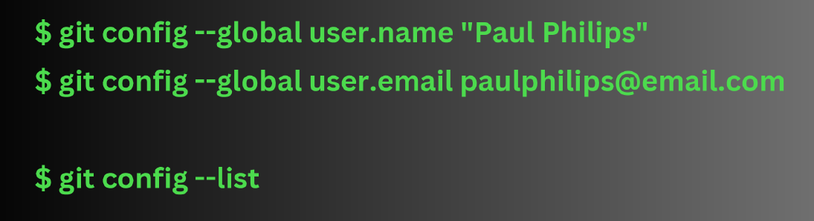

* **git config --global user.name "Aatif Jamshed"**
* **git config --global user.email** [**09.aatif@gmail.com**](mailto:09.aatif@gmail.com)
* **git config --list 🡺 To verify**

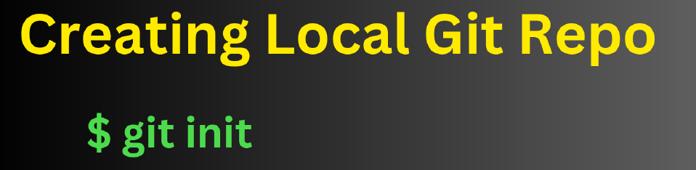

* **Get-ChildItem -Force (to see the hidden .git file)**
* **Git status**

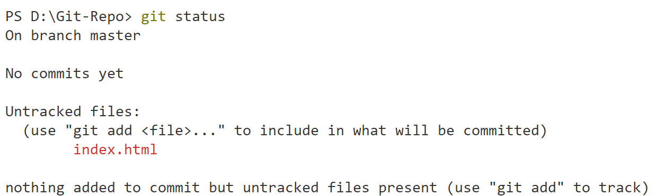

* **git add index.html**
* **git add . 🡺 to add all file changes**

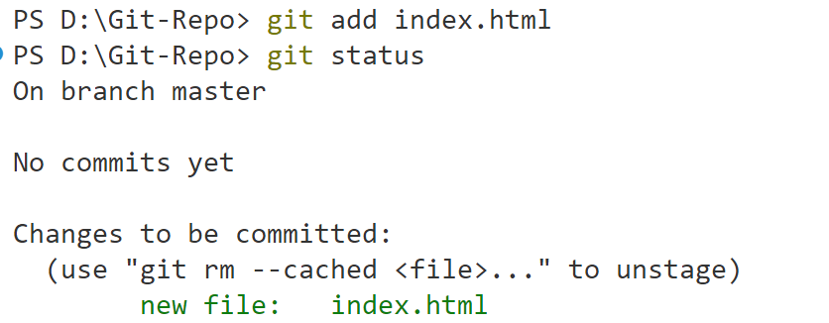

* **git commit -m "This is the 1st Version: V1"**

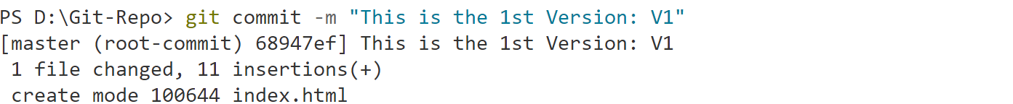

**To check the working branch:**

* **git branch**



**To check the working branch:**

* **git log**

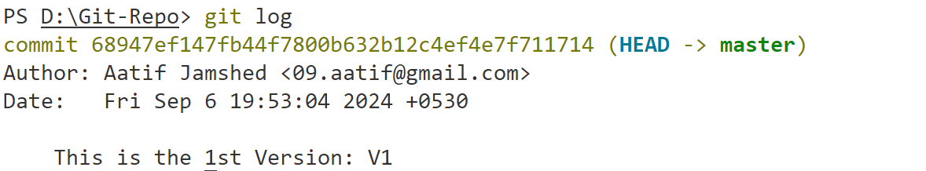

* **git status**
* **git diff**

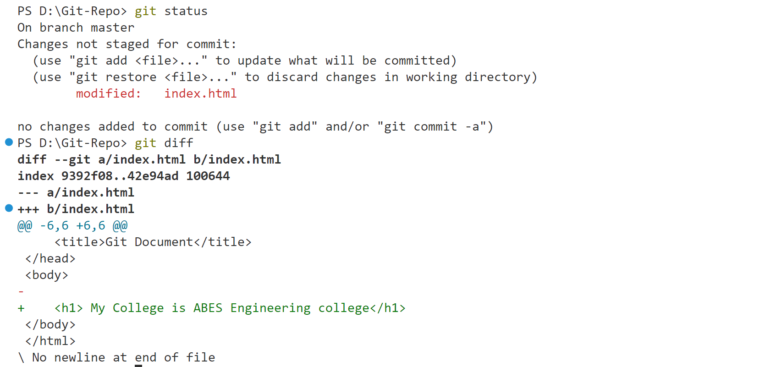

* **git add index.html**
* **git commit -m "This is the 1st Version: V2"**

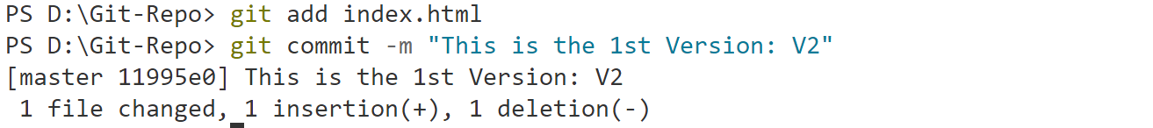

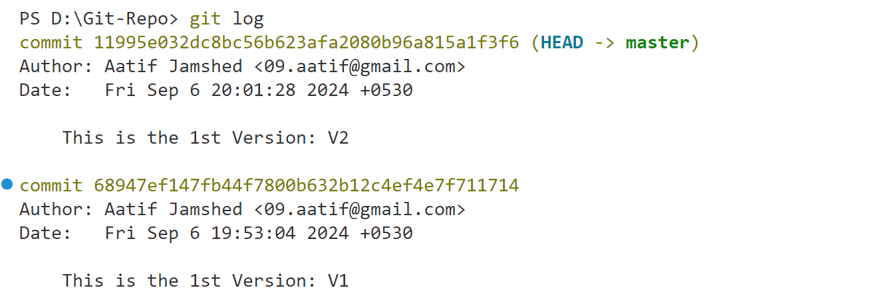

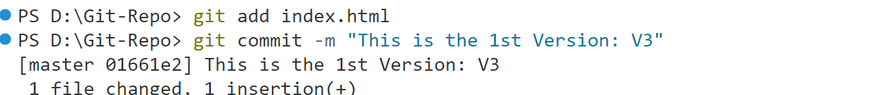

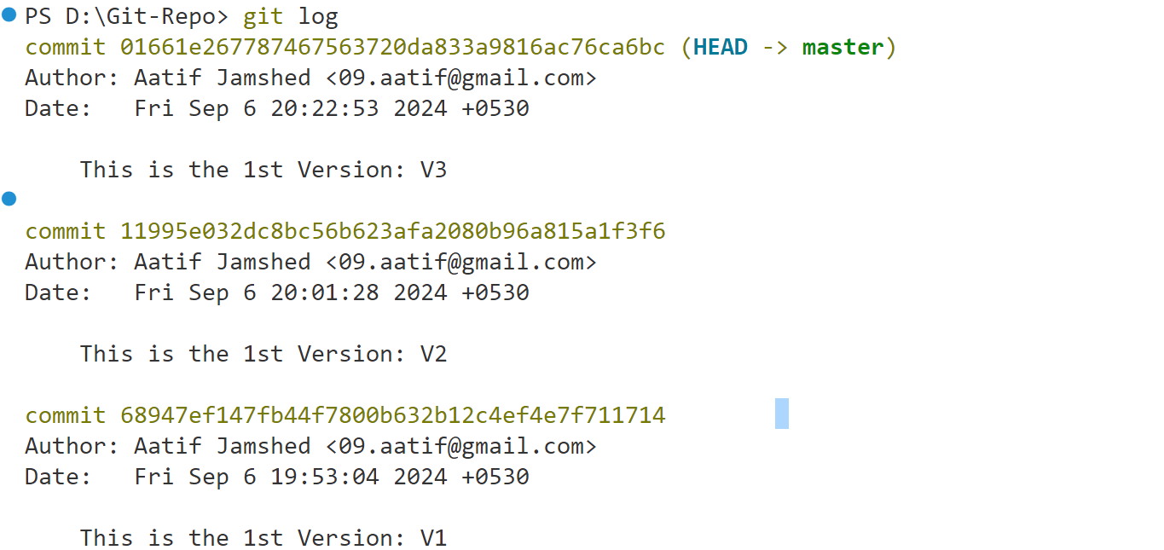

* **git show 68947ef147fb44f7800b632b12c4ef4e7f711714:index.html**

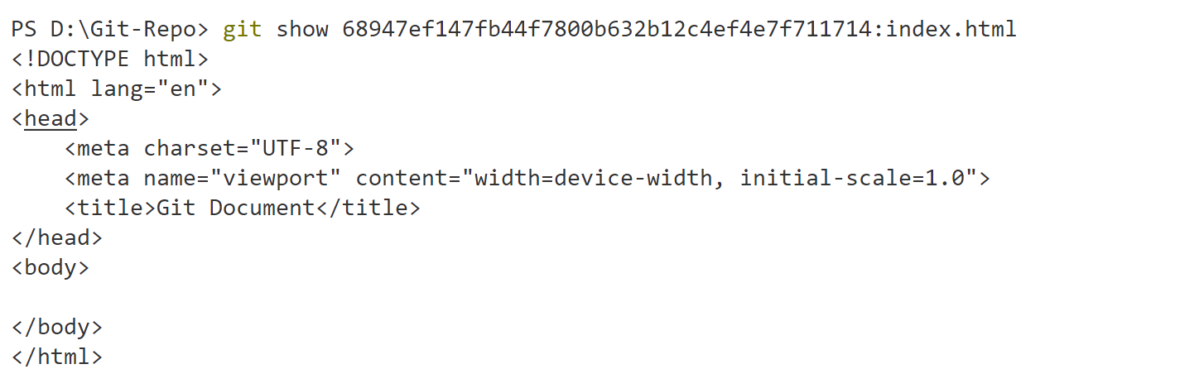

* **git checkout 68947ef147fb44f7800b632b12c4ef4e7f711714 -- \***

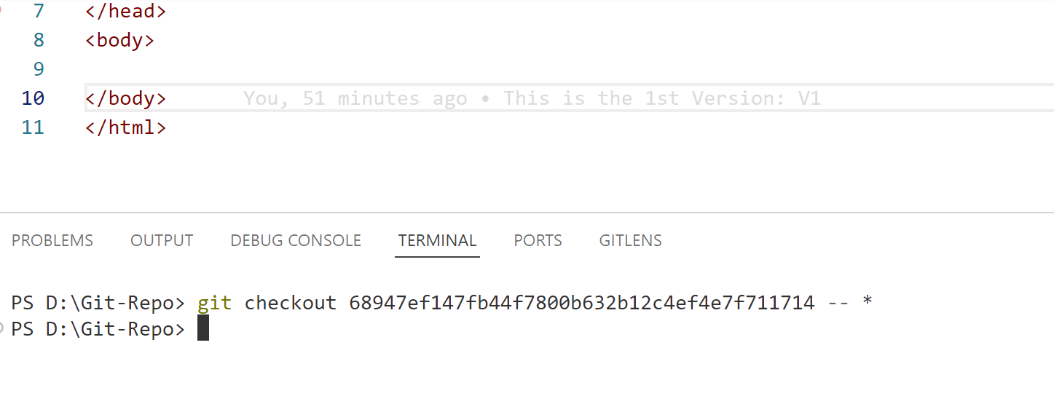

* **git checkout master -- \***

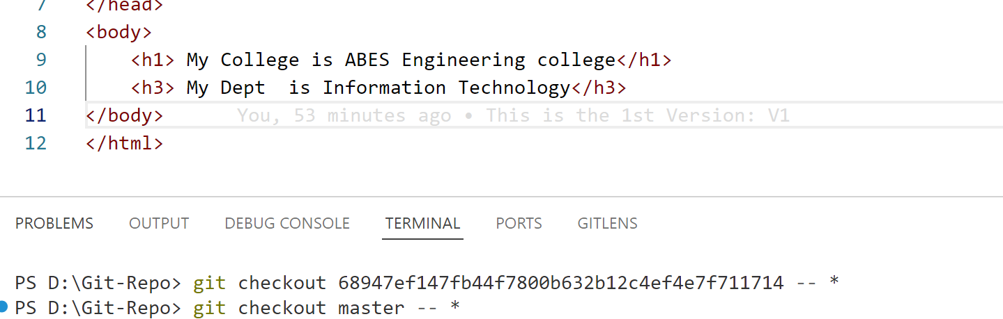

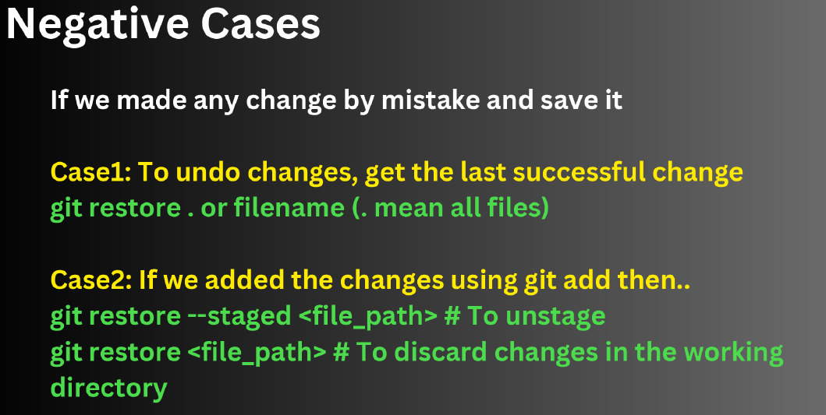

* **git restore index.html**
* **git restore .**

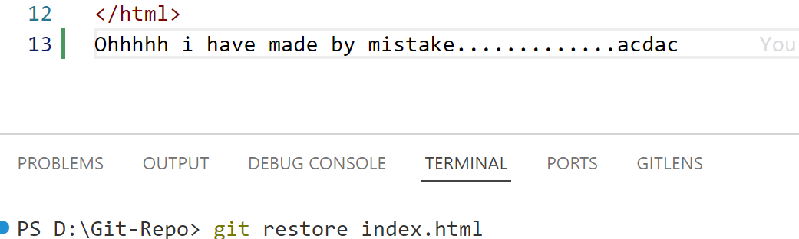

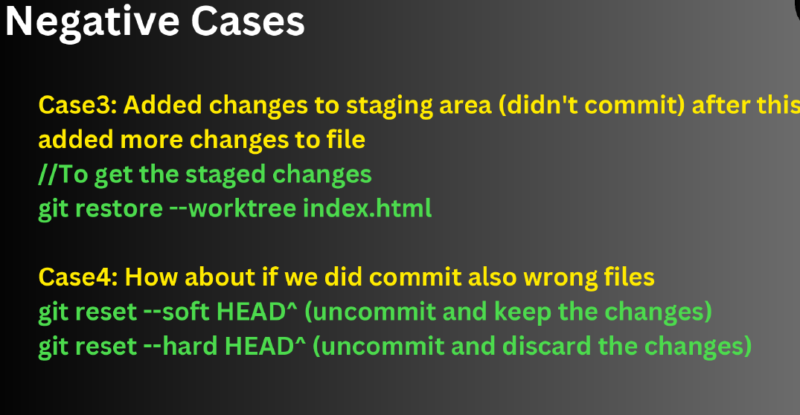

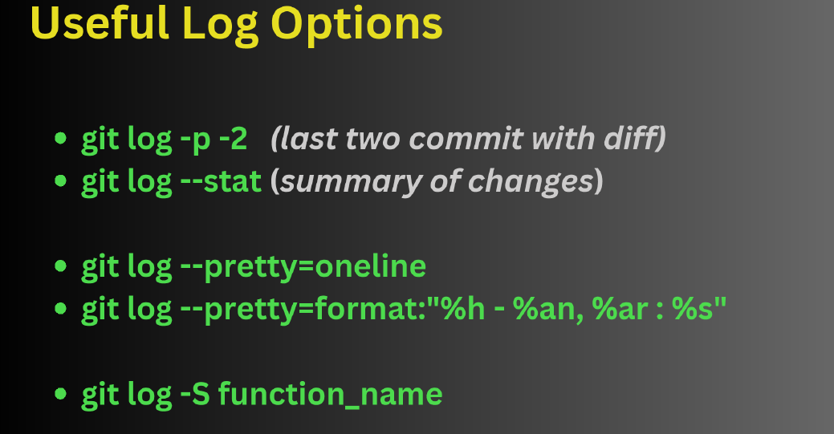

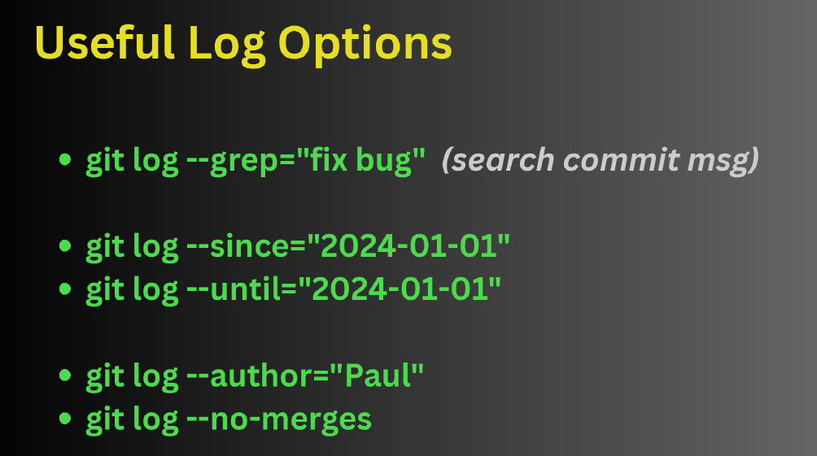

**GIT HUB**

**push an existing repository from the command line**

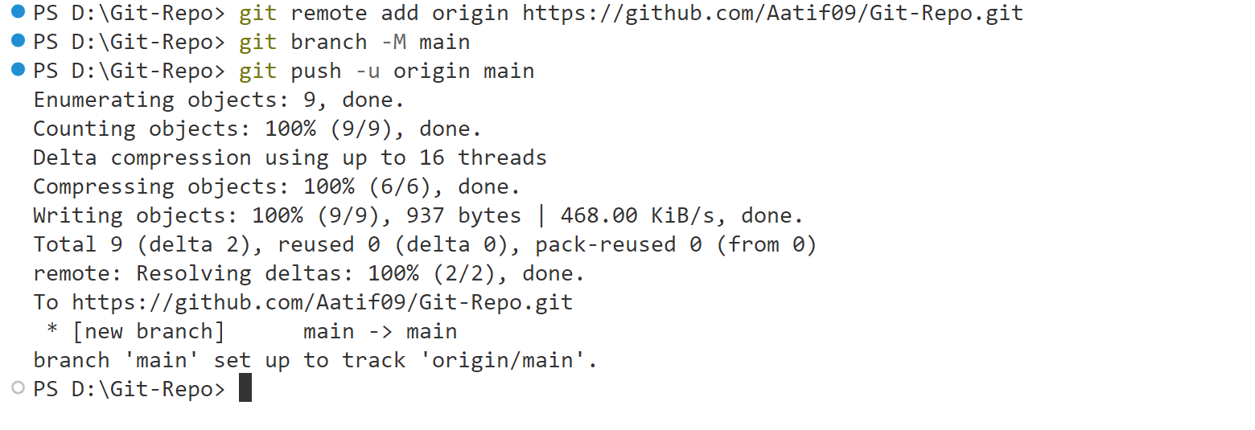

* **git remote add origin https://github.com/Aatif09/Git-Repo.git**
* **git branch -M main**
* **git push -u origin main**

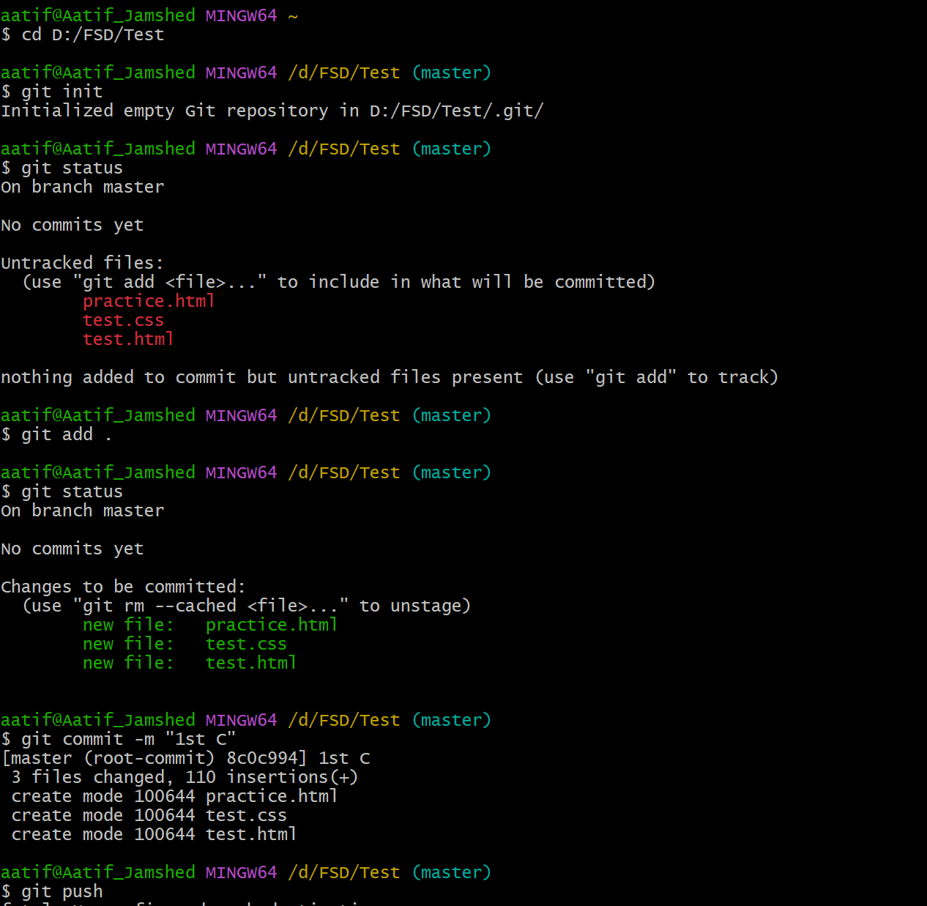

**aatif@Aatif_Jamshed MINGW64 ~**

**$ cd D:/FSD/Test**

**aatif@Aatif_Jamshed MINGW64 /d/FSD/Test (master)**

**$ git init**

**Initialized empty Git repository in D:/FSD/Test/.git/**

**aatif@Aatif_Jamshed MINGW64 /d/FSD/Test (master)**

**$ git status**

**On branch master**

**No commits yet**

**Untracked files:**

**(use "git add <file>..." to include in what will be committed)**

**practice.html**

**test.css**

**test.html**

**nothing added to commit but untracked files present (use "git add" to track)**

**aatif@Aatif_Jamshed MINGW64 /d/FSD/Test (master)**

**$ git add .**

**aatif@Aatif_Jamshed MINGW64 /d/FSD/Test (master)**

**$ git status**

**On branch master**

**No commits yet**

**Changes to be committed:**

**(use "git rm --cached <file>..." to unstage)**

**new file: practice.html**

**new file: test.css**

**new file: test.html**

**aatif@Aatif_Jamshed MINGW64 /d/FSD/Test (master)**

**$ git commit -m "1st C"**

**[master (root-commit) 8c0c994] 1st C**

**3 files changed, 110 insertions(+)**

**create mode 100644 practice.html**

**create mode 100644 test.css**

**create mode 100644 test.html**

**aatif@Aatif_Jamshed MINGW64 /d/FSD/Test (master)**

**$ git push**

**fatal: No configured push destination.**

**Either specify the URL from the command-line or configure a remote repository using**

**git remote add <name> <url>**

**and then push using the remote name**

**git push <name>**

**aatif@Aatif_Jamshed MINGW64 /d/FSD/Test (master)**

**$ git push^C**

**aatif@Aatif_Jamshed MINGW64 /d/FSD/Test (master)**

**$ git remote add Test https://github.com/Aatif09/Test.git**

**aatif@Aatif_Jamshed MINGW64 /d/FSD/Test (master)**

**$ git push**

**fatal: The current branch master has no upstream branch.**

**To push the current branch and set the remote as upstream, use**

**git push --set-upstream Test master**

**To have this happen automatically for branches without a tracking**

**upstream, see 'push.autoSetupRemote' in 'git help config'.**

**aatif@Aatif_Jamshed MINGW64 /d/FSD/Test (master)**

**$ git push --set-upstream Test master**

**Enumerating objects: 5, done.**

**Counting objects: 100% (5/5), done.**

**Delta compression using up to 16 threads**

**Compressing objects: 100% (5/5), done.**

**Writing objects: 100% (5/5), 1.32 KiB | 1.32 MiB/s, done.**

**Total 5 (delta 0), reused 0 (delta 0), pack-reused 0 (from 0)**

**To https://github.com/Aatif09/Test.git**

**\* [new branch] master -> master**

**branch 'master' set up to track 'Test/master'.**

**aatif@Aatif_Jamshed MINGW64 /d/FSD/Test (master)**

**$ git pull**

**From https://github.com/Aatif09/Test**

**\* [new branch] Dev-Aatif -> Test/Dev-Aatif**

**\* [new branch] Dev-Ashish -> Test/Dev-Ashish**

**\* [new branch] Dev-Prashant -> Test/Dev-Prashant**

**Already up to date.**

**aatif@Aatif_Jamshed MINGW64 /d/FSD/Test (master)**

**$ git status**

**On branch master**

**Your branch is up to date with 'Test/master'.**

**Untracked files:**

**(use "git add <file>..." to include in what will be committed)**

**aa.html.txt**

**nothing added to commit but untracked files present (use "git add" to track)**

**aatif@Aatif_Jamshed MINGW64 /d/FSD/Test (master)**

**$ git checkout**

**Your branch is up to date with 'Test/master'.**

**aatif@Aatif_Jamshed MINGW64 /d/FSD/Test (master)**

**$ git checkout dev-aatif**

**Switched to a new branch 'dev-aatif'**

**branch 'dev-aatif' set up to track 'Test/dev-aatif'.**

**aatif@Aatif_Jamshed MINGW64 /d/FSD/Test (dev-aatif)**

**$ git add.**

**git: 'add.' is not a git command. See 'git --help'.**

**The most similar command is**

**add**

**aatif@Aatif_Jamshed MINGW64 /d/FSD/Test (dev-aatif)**

**$ git status**

**On branch dev-aatif**

**Your branch is up to date with 'Test/dev-aatif'.**

**Untracked files:**

**(use "git add <file>..." to include in what will be committed)**

**aa.html.txt**

**nothing added to commit but untracked files present (use "git add" to track)**

**aatif@Aatif_Jamshed MINGW64 /d/FSD/Test (dev-aatif)**

**$ git add .**

**aatif@Aatif_Jamshed MINGW64 /d/FSD/Test (dev-aatif)**

**$ git commit -m "add html v1"**

**[dev-aatif e485bbe] add html v1**

**1 file changed, 0 insertions(+), 0 deletions(-)**

**create mode 100644 aa.html.txt**

**aatif@Aatif_Jamshed MINGW64 /d/FSD/Test (dev-aatif)**

**$ git push**

**Enumerating objects: 4, done.**

**Counting objects: 100% (4/4), done.**

**Delta compression using up to 16 threads**

**Compressing objects: 100% (2/2), done.**

**Writing objects: 100% (3/3), 337 bytes | 337.00 KiB/s, done.**

**Total 3 (delta 0), reused 0 (delta 0), pack-reused 0 (from 0)**

**remote:**

**remote: Create a pull request for 'dev-aatif' on GitHub by visiting:**

**remote: https://github.com/Aatif09/Test/pull/new/dev-aatif**

**remote:**

**To https://github.com/Aatif09/Test.git**

**\* [new branch] dev-aatif -> dev-aatif**

**aatif@Aatif_Jamshed MINGW64 /d/FSD/Test (dev-aatif)**

**$ git checkout master**

**Switched to branch 'master'**

**Your branch is up to date with 'Test/master'.**

**aatif@Aatif_Jamshed MINGW64 /d/FSD/Test (master)**

**$ git merge dev-aatif**

**Updating 8c0c994..e485bbe**

**Fast-forward**

**aa.html.txt | 0**

**1 file changed, 0 insertions(+), 0 deletions(-)**

**create mode 100644 aa.html.txt**

**aatif@Aatif_Jamshed MINGW64 /d/FSD/Test (master)**

**$ git commit -m "V2"**

**On branch master**

**Your branch is ahead of 'Test/master' by 1 commit.**

**(use "git push" to publish your local commits)**

**nothing to commit, working tree clean**

**aatif@Aatif_Jamshed MINGW64 /d/FSD/Test (master)**

**$ git status**

**On branch master**

**Your branch is ahead of 'Test/master' by 1 commit.**

**(use "git push" to publish your local commits)**

**nothing to commit, working tree clean**

**aatif@Aatif_Jamshed MINGW64 /d/FSD/Test (master)**

**$ git checkout master**

**Already on 'master'**

**Your branch is ahead of 'Test/master' by 1 commit.**

**(use "git push" to publish your local commits)**

**aatif@Aatif_Jamshed MINGW64 /d/FSD/Test (master)**

**$ git merge dev-aatif -m "Hi"**

**Already up to date.**

**aatif@Aatif_Jamshed MINGW64 /d/FSD/Test (master)**

**$ git merge Dev-Aatif -m "Hi"**

**Already up to date.**

**aatif@Aatif_Jamshed MINGW64 /d/FSD/Test (master)**

**$ git checkout dev-aatif**

**Switched to branch 'dev-aatif'**

**Your branch is up to date with 'Test/dev-aatif'.**

**aatif@Aatif_Jamshed MINGW64 /d/FSD/Test (dev-aatif)**

**$ git status**

**On branch dev-aatif**

**Your branch is up to date with 'Test/dev-aatif'.**

**Untracked files:**

**(use "git add <file>..." to include in what will be committed)**

**AJ.txt**

**BB.txt**

**nothing added to commit but untracked files present (use "git add" to track)**

**aatif@Aatif_Jamshed MINGW64 /d/FSD/Test (dev-aatif)**

**$ git add .**

**aatif@Aatif_Jamshed MINGW64 /d/FSD/Test (dev-aatif)**

**$ git commit -m "New"**

**[dev-aatif 6f96145] New**

**2 files changed, 0 insertions(+), 0 deletions(-)**

**create mode 100644 AJ.txt**

**create mode 100644 BB.txt**

**aatif@Aatif_Jamshed MINGW64 /d/FSD/Test (dev-aatif)**

**$ git push**

**Enumerating objects: 3, done.**

**Counting objects: 100% (3/3), done.**

**Delta compression using up to 16 threads**

**Compressing objects: 100% (2/2), done.**

**Writing objects: 100% (2/2), 237 bytes | 237.00 KiB/s, done.**

**Total 2 (delta 1), reused 0 (delta 0), pack-reused 0 (from 0)**

**remote: Resolving deltas: 100% (1/1), completed with 1 local object.**

**To https://github.com/Aatif09/Test.git**

**e485bbe..6f96145 dev-aatif -> dev-aatif**

**aatif@Aatif_Jamshed MINGW64 /d/FSD/Test (dev-aatif)**

**$ git checkout master**

**Switched to branch 'master'**

**Your branch is ahead of 'Test/master' by 1 commit.**

**(use "git push" to publish your local commits)**

**aatif@Aatif_Jamshed MINGW64 /d/FSD/Test (master)**

**$ git merge dev-aatif**

**Updating e485bbe..6f96145**

**Fast-forward**

**AJ.txt | 0**

**BB.txt | 0**

**2 files changed, 0 insertions(+), 0 deletions(-)**

**create mode 100644 AJ.txt**

**create mode 100644 BB.txt**

**aatif@Aatif_Jamshed MINGW64 /d/FSD/Test (master)**

**$ git commit -m "Final"**

**On branch master**

**Your branch is ahead of 'Test/master' by 2 commits.**

**(use "git push" to publish your local commits)**

**nothing to commit, working tree clean**

**aatif@Aatif_Jamshed MINGW64 /d/FSD/Test (master)**

**$ git status**

**On branch master**

**Your branch is ahead of 'Test/master' by 2 commits.**

**(use "git push" to publish your local commits)**

**nothing to commit, working tree clean**

**aatif@Aatif_Jamshed MINGW64 /d/FSD/Test (master)**

**$ git push**

**Total 0 (delta 0), reused 0 (delta 0), pack-reused 0 (from 0)**

**To https://github.com/Aatif09/Test.git**

**8c0c994..6f96145 master -> master**

**aatif@Aatif_Jamshed MINGW64 /d/FSD/Test (master)**

**$ ^C**

**aatif@Aatif_Jamshed MINGW64 /d/FSD/Test (master)**

**$ ^C**

**aatif@Aatif_Jamshed MINGW64 /d/FSD/Test (master)**

**$**